Methods for checking River and Structure Conveyance

How to



Contents

Heading 1 2

Heading 2 2

Heading 3 2

# Use case

Some text.

{Link to Conveyance KBA}

# Log File Geometry Output

A relatively unknown fact is that it is possible to get ICM to output all of the link geometry into the log file. We wouldn’t recommend doing this for an entire model for instance but if you wanted to just bring your bridges into an empty network, or, wanted to investigate one bridge was which causing simulation convergence issues then follow the steps below:

* Open a new run dialogue box and bring in the model network which contains the objects you want the geometry output of
* Set the duration = 0
* Switch on the Diagnostics > Timestep Log

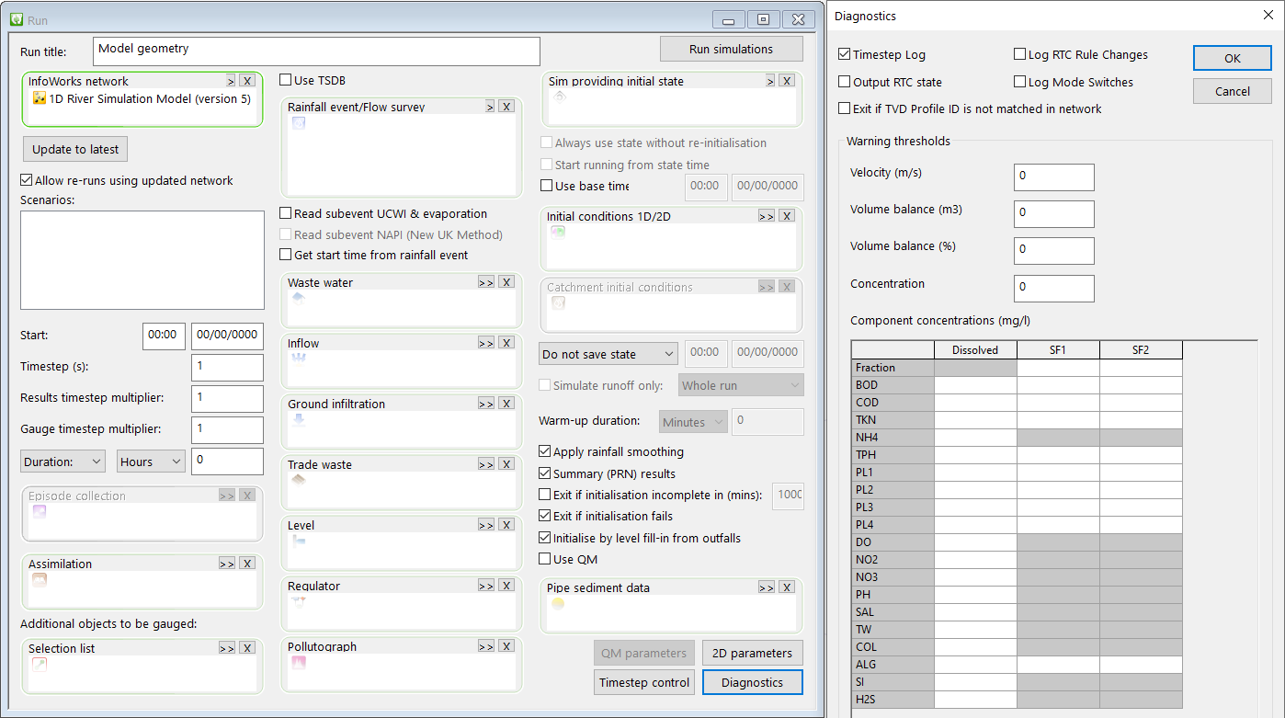

Run the simulation and then open the Log report.

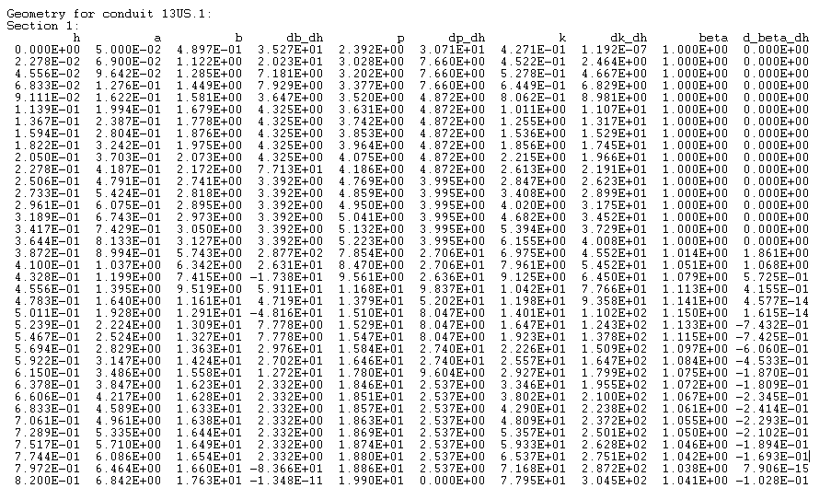

h = height, a = area, b = width, p = perimeter, k = conveyance

NEED CONFIRMATION ON WHAT THE LOG FILE MEANS AND HOW ITS LAID OUT.